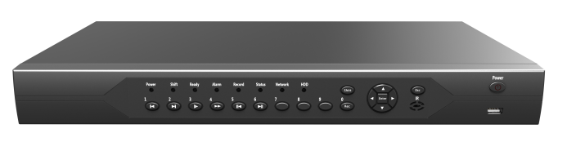
ADVR8032E-NLME
2 SATA H.265 32ch Analog HD DVR E Series

Parameters：
Features：
 | Model | ADVR8032E-NLME
System | processor | NT98336
Video | Codec | H.265+/H.265/H.264
Video | preview | 32ch 5M-N@12fps(6 in 1)/32ch 4M-N@15fps(6 in 1)/32ch 1080P@15fps(XVI),default 5M-N
Video | Encode | 32ch 5M-N@6fps(6 in 1)/32ch 4M-N@8fps(6 in 1)/32ch 1080P@8fps(XVI),default 5M-N
Video | Decode | 8ch 5M-N@6fps(6 in 1)/16ch 4M-N@8fps(6 in 1)/16ch 1080P@8fps(XVI),default 5M-N
Video | Multi-mode | Analog:32ch 5M-N/32ch 4M-N/32ch 1080N；
Video | Multi-mode | Digital to analog conversion： Unsupport  Hybird: 16ch5M-N(analog)+ 16ch5M(network)
Video | Multi-mode | IP: 32ch 4K/16ch 5M
Video | Playback | 8ch
Audio | Compression | G.711a
Audio | Intercom | Support
Management | Record mode | Manual>Alarm>Motion detection>Timing
Management | Inquire mode | Inquire by Time/Calendar/Event/Channel
Management | Storage mode | HDD Storage, Network Storage
Management | Backup | Network, USB, SATA
Interface | Video input | 32*BNC（Support Coaxitron）
Interface | HDMI output | 1*HDMI (MAX:4K)
Interface | VGA output | 1*VGA (MAX:1080P)
Interface | Audio I/O | 16/1
Interface | Alarm I/O | 8/1
Interface | Ethernet port | 1*10/100/1000Mbps Ethernet port, RJ45 port
Interface | PTZ control | 1*RS485,1个RS232；Support for multiple PTZ protocol
Interface | USB Port | 2*USB2.0 ports
Interface | HDD | 2*SATA interface (Up to 14TB)
General | Temperature | 0 ℃ - + 55 ℃
General | Humidity | 10% -90% RH
General | Power supply | 12V/4A
General | Consumption | <10W（Without HDD）
General | Weight | Around 3KG
General | Dimension | 440mm(L)* 290mm(W)* 50mm(H)

- Support 32ch 5M-N unreal-time encoding;
- Support AHD, TVI, CVI,CVBS, IP video input;
- HDMI/VGA video output;
- BIG 1U Case, 2 SATA(Up to 8TB);
- 1*10/100/1000Mbps auto-sensing Ethernet port, RJ45 port；
- Automatic networking support, a key to add equipment;
- Support the Onvif protocol;
- Support GB28181 (Optional);
- Cloud services, P2P, alarm information push to phone;
- Support remote access, support ARSP;
- Support DHCP, FTP, DNS, DDNS, NTP, UPNP, EMAIL,
3G, WIFI, IP search, Alarm center, etc ;
- Mobile phone remote monitoring (iOS, Android);
- Multi browser access (IE, Chrome, Firefox, Safari);
- Support for more than twenty languages;
- Perfect protection circuit,unique triple watchdog function
- Support WEB, CMS, VMS, MYEYE Platform;
- Support coaxial control
- Support intelligent analysis: Human shape detection, face detection, car shape detection

Model：
ADVR8032E-NLME
Interface：

