AHB7008T-LY-V3
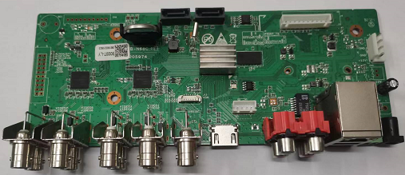
Feature：
- Support H.265+ encoding, ultra-low bitrates, compatible with H.264 surroundings
- Support CVBS、VGA, HDMI full HD output simultaneously
- Support ONVIF; access third party
- Support multiple cloud technology, network penetration, alarm information pushed to your phone and other functions
- Support web, VMS, center platform management software MYEYE, provide SDK development
- Support various mobile monitoring (iPhone, Android)
- Remote Access, With DNS (ARSP),easy to monitor remotely
- Support UTC, control signal& video stream transmit through one single coaxial
- Support XVI/AHD/TVI/CVI/CVBS/IP six signals
- Support intelligent analysis: Human detection, face detection, Vehicle shape detection;
Specification：
 | Model | AHB7008T-LY-V3
System | Main processor | NT98331
Interface | Preview | 1/4/8/9
Video | Codec | H.265+
Video | Monitor quality | CVBS、VGA(1080P at most);HDMI(2K at most)
Video | Preview ability | 8*1080N (6 in 1)/4*5M-N (6 in 1)
Video | Encode ability | 8*1080N@15 fps(6 in 1)/4*5M-N@20fps(6 in 1)
Video | Decode ability | 8*1080N@15 fps(6 in 1)/4*5M-N@20fps(6 in 1)
Video | Multi-mode  input | Analog：8*1080N；4*5M-N  hybrid：8*1080N（analog）+2*1080P（network）  Network：16*1080P；8*5M
Video | Motion Detection | Each screen can be set to 192 (16 * 12) detection areas; multi-level sensitivity can be set (Limited local channel)
Audio | Coaxial audio | support
Audio | Audio compression | G.711A
Audio | Intercom | support
Record & playback | Record mode | manual>alarm>motion detection>timing
Record & playback | Local Playback | 4ch(analog input mode)
Record & playback | Search mode | Search by time, calendar, event, channel
Storage & backup | Video storage | HDD, network
Storage & backup | Backup mode | Network, USB hard disk, USB burner, SATA burner
External Interface | Video input | 8ch BNC
External Interface | Video output | 1ch VGA, 1ch HDMI
External Interface | Loop Vout | N/A
External Interface | Audio I/O | 4/1
External Interface | Alarm I/O | 4/1
External Interface | Network interface | RJ45 10M/100M self-adaption
External Interface | PTZ control | Support kinds of PTZ protocols
External Interface | USB | 2* USB 2.0 ports
External Interface | HDD | 1*SATA ports (Max 14TB/per)
External Interface | Wireless | 3G, WIFI (extend via USB)
General | Power supply | 12V/2A
General | Power Consumption | <15W (without HDD)
General | Working environment | Temperature:0℃—+55℃，Humidity:10%—90%，Atm:86kpa—106kpa
General | Dimension | 170mm*60mm
General | Weight | 124g
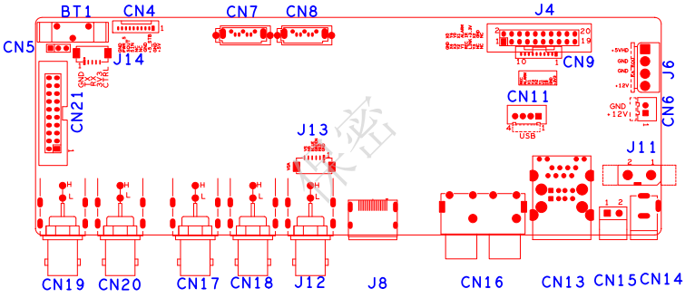
Socket | Function | Interface Description
J8 | 10PIN without MCU  front panel socket | 1、+3.3 | 2、GND | 3、FRONT_IR | 4、FRONT_Y2
J8 | 10PIN without MCU  front panel socket | 5、FRONT_Y1 | 6、FRONT_X2 | 7、FRONT_Y3 | 8、FRONT_X1
J8 | 10PIN without MCU  front panel socket | 9、FRONT_ALARM | 10、FRONT_REC
CN2，CN3 | SATA
CN11 | USB expansion seat | 1、+5 | 2、DM | 3、DP | 4、GND
CN4 | MCU front panel socket | 1、+5 | 2、GND | 3、+5_STB | 4、GND
CN4 | MCU front panel socket | 5、 | 6、 | 7、SIN | 8、SOUT
CN4 | MCU front panel socket | 9、PWR_S | 10、GND
CN6 | FAN power socket | 1、+12 | 2、GND
J14 | 433 | 1、GND | 2、SOUT | 3、SIN | 4、+3.3
J6 | SATA power socket
CN14 | 12V input
CN13 | 2USB+RJ45
J12 | Audio output seat /  CVBS output seat
J13 | VGA
J3 | HDMI
J4 | CVBS
CN17，CN18  CN19，CN20 | BNC
CN21 | AL expansion seatt
BT1 | RTC Battery seat

