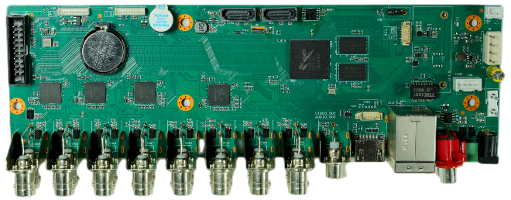
AHB7016T-LY-V3

Feature：
- Support H.265+ encoding, ultra-low bitrates, compatible with H.264 surroundings;
- Support HDMI full HD output simultaneously;
- Support ONVIF; access third party;
- Support multiple cloud technology, network penetration, alarm information pushed to your phone and other functions;
- Support web, VMS, center platform management software MYEYE, provide SDK development;
- Support various mobile monitoring (iPhone, Android);
- Remote Access, With DNS (ARSP),easy to monitor remotely
- Support UTC, control signal& video stream transmit through one single coaxial
- Support XVI/AHD/TVI/CVI/CVBS/IP six signals;
- Support intelligent analysis: Human detection, face detection, Vehicle shape detection;
Specification：
 | Model | AHB7016T-LY-V3
System | Main processor | NT98332
Interface | Preview | 1/4/8/9/16
Video | Codec | H.265+
Video | Monitor quality | CVBS、VGA (1080P at most)；HDMI (4K at most)
Video | Preview ability | 16*1080N(6 in 1)
Video | Encode ability | 16*1080N@15fps(6 in 1)
Video | Decode ability | 16*1080N@15fps(6 in 1)
Video | Multi-mode  input | Analog：16*1080N  hybrid：8*1080N（analog）+8*1080P（network）  network：16*1080P；4*5M
Video | Motion Detection | Each screen can be set to 192 (16 * 12) detection areas; multi-level sensitivity can be set (Limited local channel)
Audio | Coaxial audio | support
Audio | Audio compression | G.711A
Audio | Intercom | support
Record & playback | Record mode | manual>alarm>motion detection>timing
Record & playback | Local Playback | 16ch(analog input mode)
Record & playback | Search mode | Search by time, calendar, event, channel
Storage & backup | Video storage | HDD, network
Storage & backup | Backup mode | Network, USB hard disk, USB burner, SATA burner
External Interface | Video input | 16ch BNC
External Interface | Video output | 1ch HDMI（Can be extended to VGA*1）
External Interface | Loop Vout | N/A
External Interface | Audio I/O | 2（Can be extended to 6ch）/1
External Interface | Alarm I/O | 0（Can be extended to 4ch）/0（Can be extended to 1ch）
External Interface | Network interface | RJ45 10M/100M self-adaption
External Interface | PTZ control | 1*RS485, Support kinds of PTZ protocols
External Interface | USB | 2* USB 2.0 ports
External Interface | HDD | 2*SATA ports (Max 8TB/per)
External Interface | Wireless | 3G, WIFI (extend via USB)
General | Power supply | 12V/2A
General | Power Consumption | <15W (without HDD)
General | Working environment | Temperature:0℃—+55℃，Humidity:10%—90%，Atm:86kpa—106kpa
General | Dimension | 239mm*85mm
General | Weight | 248g
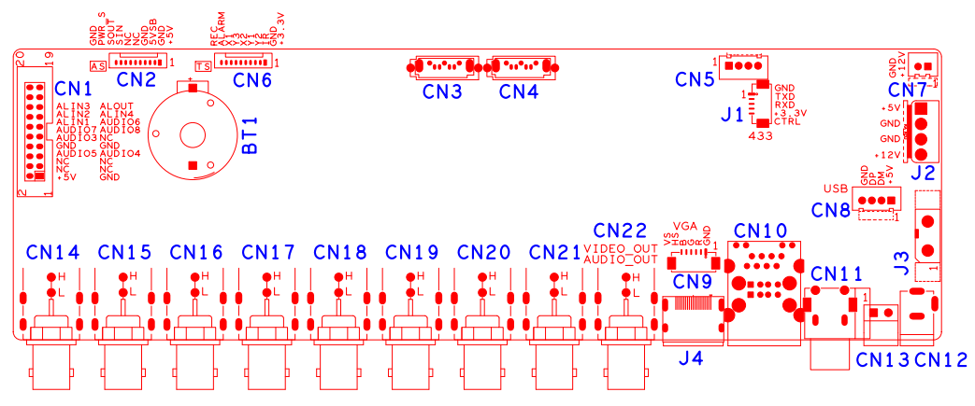
No. | Interface Description | Function
CN6 | 10PIN front panel socket | 1、+3.3 | 2、GND | 3、FRONT_IR | 4、FRONT_Y2
CN6 | 10PIN front panel socket | 5、FRONT_Y1 | 6、FRONT_X2 | 7、FRONT_Y3 | 8、FRONT_X1
CN6 | 10PIN front panel socket | 9、FRONT_ALARM | 10、FRONT_REC
J2 | SATA power socket
CN3,CN4 | SATA
CN5
CN8 | USB expansion seat | 1、+5 | 2、DM | 3、DP | 4、GND
CN2 | MCU front panel socket | 1、+5 | 2、GND | 3、+5_STB | 4、GND
CN2 | MCU front panel socket | 5、 | 6、 | 7、SIN | 8、SOUT
CN2 | MCU front panel socket | 9、PWR_S | 10、GND
CN7 | FAN power socket | 1、+12 | 2、GND
CN13 | 485 | 1、RS485_A | 2、RS485_B
CN11 | Audio input
J1 | 433 | 1、GND | 2、SOUT | 3、SIN | 4、+3.3
J3 | Switch terminal
CN12 | 12V input
CN10 | RJ45+2*USB
CN9 | VGA
J4 | HDMI
CN14-CN21 | BNC
CN1 | Audio&alarm expansion seat | 1、GND | 2、+5 | 3、 | 4、
CN1 | Audio&alarm expansion seat | 5、 | 6、 | 7、AUDIO6 | 8、AUDIO7
CN1 | Audio&alarm expansion seat | 9、GND | 10、GND | 11、AUDIO2 | 12、AUDIO5
CN1 | Audio&alarm expansion seat | 13、AUDIO4 | 14、AUDIO3 | 15、AUDIO8 | 16、ALARM_IN1
CN1 | Audio&alarm expansion seat | 17、ALARM_IN4 | 18、ALARM_IN2 | 19、ALOUT1 | 20、ALARM_IN3
CN22 | Audio output seat /  CVBS output seat
BT1 | RTC Battery seat

