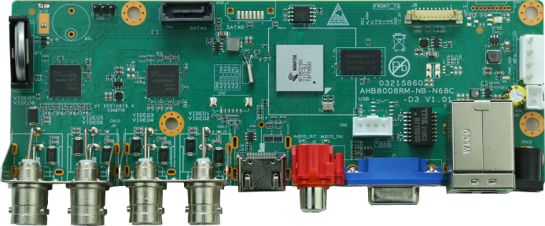
AHB80N08RM-LME
Feature：
- Support H.265+ encoding, ultra-low bitrates, compatible with H.264 surroundings
- Support VGA, HDMI full HD output simultaneously
- Support ONVIF; access third party
- Support multiple cloud technology, network penetration, alarm information pushed to your phone and other functions
- Support web, VMS, center platform management software MYEYE, provide SDK development
- Support various mobile monitoring (iPhone, Android)
- Remote Access, With DNS (ARSP),easy to monitor remotely
- Support UTC, control signal& video stream transmit through one single coaxial
- Support XVI/AHD/TVI/CVI/CVBS/IP six signals
- Support intelligent analysis: Human detection, face detection
Specification：
 | Model | AHB80N08RM-LME
System | Main processor | NT98321
Interface | Preview | 1/4/8/9
Video | Codec | H.265+
Video | Monitor quality | VGA(1080P at most);HDMI(2K at most)
Video | Preview ability | 8*5M-N@12fps(6 in 1)/ 8*4M-N@15fps（6 in 1）/  8*1080P@15fps（XVI），default:5M-N
Video | Encode ability | 8*5M-N@12fps(6 in 1)/ 8*4M-N@15fps（6 in 1）/  8*1080P@15fps（XVI），default:5M-N
Video | Decode ability | 8*5M-N@12fps(6 in 1)/ 8*4M-N@15fps（6 in 1）/  8*1080P@15fps（XVI），default:5M-N
Video | Multi-mode  input | Analog：8*5M-N  hybrid：8*5M-N（analog）+4*1080P（network）  Network：16*1080P；8*5M
Video | Motion Detection | Each screen can be set to 192 (16 * 12) detection areas; multi-level sensitivity can be set (Limited local channel)
Audio | Audio compression | G.711A
Audio | Intercom | support
Record & playback | Record mode | manual>alarm>motion detection>timing
Record & playback | Local Playback | 4ch(analog input mode)
Record & playback | Search mode | Search by time, calendar, event, channel
Storage & backup | Video storage | HDD, network
Storage & backup | Backup mode | Network, USB hard disk, USB burner, SATA burner
External Interface | Video input | 8ch BNC
External Interface | Video output | 1ch VGA, 1ch HDMI
External Interface | Loop Vout | N/A
External Interface | Audio I/O | 1/1
External Interface | Alarm I/O | 0/0
External Interface | Network interface | RJ45 10M/100M self-adaption
External Interface | PTZ control | Support kinds of PTZ protocols
External Interface | USB | 2* USB 2.0 ports
External Interface | HDD | 2*SATA ports (Max 14TB/per)
External Interface | Wireless | 3G, WIFI (extend via USB)
General | Power supply | 12V/2A
General | Power Consumption | <15W (without HDD)
General | Working environment | Temperature:0℃—+55℃，Humidity:10%—90%，Atm:86kpa—106kpa
General | Dimension | 170mm*60mm
General | Weight | 124g
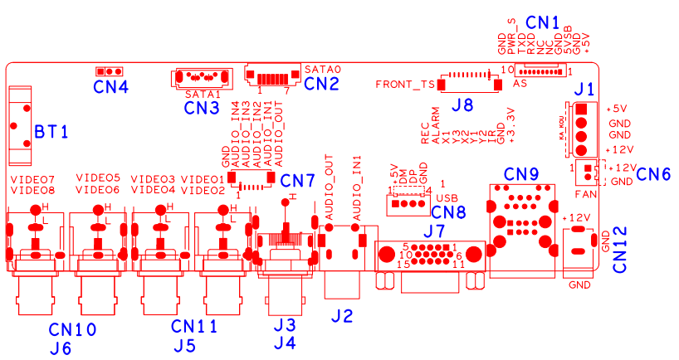
Socket | Function | Interface Description
CN4 | Debug UART | 1:RX | 2:TX | 3:GND
BT1 | Battery seat
CN3 | SATA1
CN2 | SATA0
J8 | 10PIN without MCU  front panel socket | 1：+3.3 | 2：GND | 3：FRONT_IR | 4：FRONT_Y2
J8 | 10PIN without MCU  front panel socket | 5：FRONT_Y1 | 6：FRONT_X2 | 7：FRONT_Y3 | 8：FRONT_X1
J8 | 10PIN without MCU  front panel socket | 9：ALARM | 10：REC
CN1 | 10PIN MCU front panel socket | 1：+5 | 2：GND | 3：+5_STB | 4：GND
CN1 | 10PIN MCU front panel socket | 5：NC | 6：NC | 7：X_UART1_SIN | 8：X_UART1_SOUT
CN1 | 10PIN MCU front panel socket | 9：PWR_S | 10：GND
J1 | SATA power socket
CN6 | FAN power socket
CN12 | 12V input
CN9 | 2*USB+RJ45
CN8 | USB expansion seat
J7 | VGA
J2 | Audio seat | up：input | down：output
CN7 | Audio expansion seat
J3 | HDMI
J4 | CVSB
CN11 | BNC Video input | Right up:VIDEO1 | Right down:VIDEO2 | Left up:VIDEO3 | Left  down:VIDEO4
CN10 | BNC Video input | Right up：VIDEO5 | Right down:VIDEO6 | Left up:VIDEO7 | Left  down：VIDEO8

